***The Ninth Sunday of Pentecost***

***July 21, 2024***

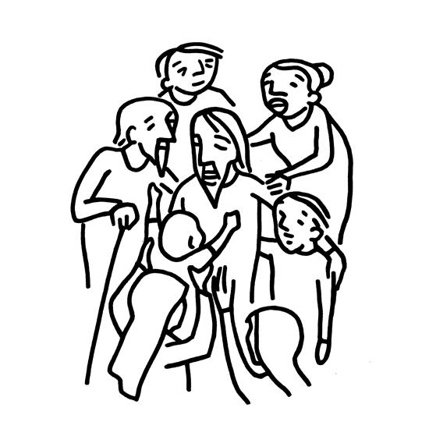

***Lutheran Church of the Good Shepherd***

***383 Old North Rd.***

***Kingston, RI 02881***

***Reverend Dennis Kohl, Pastor***

***Heather Skidds, Minister of Music***

***Welcome to Our Visitors***

In our busy world, we thank God for many things, especially your presence here. We consider it a blessing to have you among us as we gather together as people of God!

We love having guests (and celebrating your return as friends) and want to make sure you always feel welcomed.   If you’re part of another community, we look forward to hearing all about it, and we look forward to welcoming you back when you can visit again!

Sunday is a time to unplug from our busy, distracted lives, and turn back to our God.  Our worship service offers God’s gifts of Liturgy (the order of worship), God’s Word (through Scripture and Sermon), Prayer, and the Sacrament of Holy Communion.

**We are** **a “Reconciling in Christ” church of the ELCA**.  It means that we affirm + accept all people regardless of age, race, ethnicity, legal status, economic situation, sexual orientation, gender identity, marital status, physical or emotional conditions, and whatever else we didn’t list here.  **We believe that God creates us ALL in the image of God, and loves us unconditionally,** and helps us to do the same with everyone.  **We also believe** God desires that everyone should have the opportunity to participate in the life and worship of a faith community.  **We’re glad you’re here!**

**Assistants for today-**  **Assisting Minister-** Fred Baillargeron

**Lector**- Ralph Stokes

**Greeter/Usher**- Kris Bacon

**Communion Assistant**- Karen Amitrano

**Altar set up**- Ann Lessmann

**Assistants for 7-28-24-** **Assisting Minister-** Marie Bender Lee

**Lector**- Fred Baillargeron

**Greeter/Usher**- Riitta Passananti

**Communion Assistant**- Jean Vican

**Altar set up**- Annie Senerchia

**+GATHERING+**

**Prelude-** Draw Me into Your Presence, by Teresa Muller

*Stand*

**Confession and Forgiveness**

Blessed be the Holy Trinity, + one God, who creates, redeems, and

sustains us and all creation. **Amen.**

Let us confess our sins in the presence of God and of one another.

*Silence is kept for reflection.*

To you, O God,

**all hearts are open, to you all desires known. We come to you,**

**confessing our sin. Forgive us in your mercy, and remember us in**

**your love. Show us your ways; teach us your paths; and lead us in**

**justice and truth, for the sake of your goodness in Jesus Christ our**

**savior. Amen.**

*The presiding minister announces God’s forgiveness*

By water and the Holy Spirit God gives you a new birth, and through the

death and resurrection of + Jesus Christ, God forgives you all your sin.

The God of mercy and might strengthen you in all goodness and keep you

in eternal life. **Amen.**

**Gathering Hymn- *ELW 431 All Who Hunger, Gather Gladly***

The grace of our Lord Jesus Christ, the love of God, and the fellowship of the Holy Spirit be with you all.  
**And also with you.**

**PRAYER OF THE DAY** Let us pray.  
O God, **powerful and compassionate, you shepherd your people, faithfully feeding and protecting us. Heal each of us, and make us a whole people, that we may embody the justice and peace of your Son, Jesus Christ, our Savior and Lord. Amen.**

**+WORD+**

### *Sit***First Reading: Jeremiah 23:1-6**

1 Woe to the shepherds who destroy and scatter the sheep of my pasture! says the Lord. 2 Therefore thus says the Lord, the God of Israel, concerning the shepherds who shepherd my people: It is you who have scattered my flock, and have driven them away, and you have not attended to them. So I will attend to you for your evil doings, says the Lord. 3 Then I myself will gather the remnant of my flock out of all the lands where I have driven them, and I will bring them back to their fold, and they shall be fruitful and multiply. 4 I will raise up shepherds over them who will shepherd them, and they shall not fear any longer, or be dismayed, nor shall any be missing, says the Lord.  
  5 The days are surely coming, says the Lord, when I will raise up for David a righteous Branch, and he shall reign as king and deal wisely, and shall execute justice and righteousness in the land. 6 In his days Judah will be saved and Israel will live in safety. And this is the name by which he will be called: “The Lord is our righteousness.” Word of God. Word of Life.  **Thanks be to God.**

**Psalm: Psalm 23**

To be sung

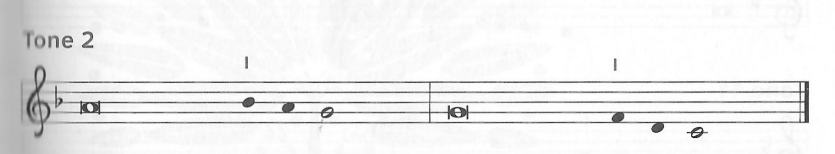

### 

 1 The Lord **|** is my shepherd;  
  I shall not **|** be in want.  
 2 **The Lord makes me lie down | in green pastures**  
  **and leads me be- | side still waters.**  
 3 You restore my **|** soul, O Lord,  
  and guide me along right pathways **|** for your name’s sake.  
 4 **Though I walk through the valley of the shadow of death, I shall | fear no evil;**  
  **for you are with me; your rod and your staff, they | comfort me.**   
 5 You prepare a table before me in the presence **|** of my enemies;  
  you anoint my head with oil, and my cup is **|** running over.  
 6 **Surely goodness and mercy shall follow me all the days | of my life,**  
  **and I will dwell in the house of the | Lord forever. Amen**

**Second Reading: Ephesians 2:11-22**

11 Remember that at one time you Gentiles by birth, called “the uncircumcision” by those who are called “the circumcision”—a physical circumcision made in the flesh by human hands—12 remember that you were at that time without Christ, being aliens from the commonwealth of Israel, and strangers to the covenants of promise, having no hope and without God in the world. 13 But now in Christ Jesus you who once were far off have been brought near by the blood of Christ. 14 For he is our peace; in his flesh he has made both groups into one and has broken down the dividing wall, that is, the hostility between us. 15 He has abolished the law with its commandments and ordinances, that he might create in himself one new humanity in place of the two, thus making peace, 16 and might reconcile both groups to God in one body through the cross, thus putting to death that hostility through it. 17 So he came and proclaimed peace to you who were far off and peace to those who were near; 18 for through him both of us have access in one Spirit to the Father. 19 So then you are no longer strangers and aliens, but you are citizens with the saints and also members of the household of God, 20 built upon the foundation of the apostles and prophets, with Christ Jesus himself as the cornerstone. 21 In him the whole structure is joined together and grows into a holy temple in the Lord; 22 in whom you also are built together spiritually into a dwelling place for God.

Word of God. Word of Life.  **Thanks be to God.**

*Stand*

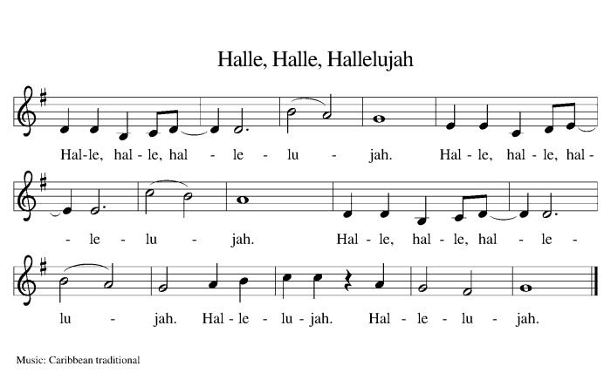

**Gospel: Gospel: Mark 6:30-34, 53-56**

The holy Gospel according to Mark.  
**Glory to you, O Lord.**

30 The apostles gathered around Jesus, and told him all that they had done and taught. 31 He said to them, “Come away to a deserted place all by yourselves and rest a while.” For many were coming and going, and they had no leisure even to eat. 32 And they went away in the boat to a deserted place by themselves. 33 Now many saw them going and recognized them, and they hurried there on foot from all the towns and arrived ahead of them. 34 As he went ashore, he saw a great crowd; and he had compassion for them, because they were like sheep without a shepherd; and he began to teach them many things.  
  53 When they had crossed over, they came to land at Gennesaret and moored the boat. 54 When they got out of the boat, people at once recognized him, 55 and rushed about that whole region and began to bring the sick on mats to wherever they heard he was. 56 And wherever he went, into villages or cities or farms, they laid the sick in the marketplaces, and begged him that they might touch even the fringe of his cloak; and all who touched it were healed.

The Gospel of our Lord.  
**Praise to you, O Christ.**

*Sit***SERMON**

*Stand*

**HYMN OF THE DAY- *ELW 611 I Heard the Voice of Jesus Say***

**Apostles Creed***Baptized into Christ, with the whole Church, let us confess our faith.*

**I believe in God, the Father almighty,**

**creator of heaven and earth.**

**I believe in Jesus Christ, God’s only Son, our Lord,**

**who was conceived by the Holy Spirit,**

**born of the virgin Mary,**

**suffered under Pontius Pilate,**

**was crucified, died, and was buried;**

**he descended to the dead.**

**On the third day he rose again;**

**he ascended into heaven,**

**he is seated at the right hand of the Father,**

**and he will come to judge the living and the dead.**

**I believe in the Holy Spirit,**

**the holy catholic church,**

**the communion of saints,**

**the forgiveness of sins,**

**the resurrection of the body,**

**and the life everlasting. Amen.**

**PRAYERS OF INTERCESSION  
AM:** Each petition concludes In your mercy, **hear our prayer.**

*The pastor concludes the prayers***PR:** Holy God, holy and merciful: into your outstretched arms we commend ourselves and all for whom we pray, trusting in the one who is the way, the truth, and the life, Jesus Christ our Savior and Lord. **Amen.**

**PEACE**

The peace of Christ be with you.  **And also with you.***A sign of peace and reconciliation is shared among worshippers.*

*Sit*

*AM sets the table*

**Musical Offering:** Oceans (Where Feet May Fall).(summer singers)

*AM collects offering in front of altar.*

*Our offering is presented for the work of the church locally and throughout the world.*

*Stand*

**Offering Prayer**

### **AM:** Let us pray: Jesus, Bread of life, **you have set this table with your very self, and called us to the feast of plenty. Gather what has been sown among us, and strengthen us in this meal. Make us to be what we receive here, your body for the life of the world.** **Amen.**

**+MEAL+**

**THE GREAT THANKSGIVING**The Lord be with you. **And also with you.**

Lift up your hearts. **We lift them to the Lord.**

Let us give thanks to the Lord our God.

**It is right to give God thanks and praise**.

*The pastor prays the preface for the congregation.*It is indeed right, our duty and our joy,

that we should at all times and in all places

give thanks and praise to you, almighty and merciful God,

through our Savior Jesus Christ;

who on this day overcame death and the grave,

and by his glorious resurrection opened to us the way of everlasting life.

And so, with all the choirs of angels,

with the church on earth and the hosts of heaven,

we praise your name and join their unending hymn:

**Sanctus**

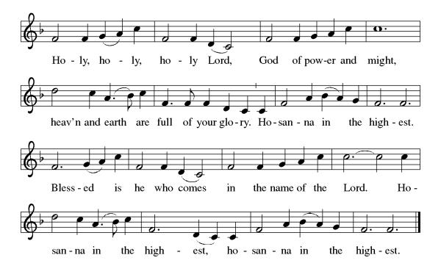

*The pastor and congregation pray the Thanksgiving at the Table.*Holy God, our Maker, Redeemer, and Healer…Remembering therefore his acts of healing…we await that day when Jesus will return and make us whole. **Amen.  Come, Lord Jesus**

**…**.Send your Spirit…that all may be fed with your Son, the bread of Life. **Amen.  Come, Holy Spirit.**

Through him…in your holy Church both now and forever.  **Amen.**

*Gathered into one by the holy spirit, let us pray as Jesus taught us.*

**Our Father...**

**Invitation to communion:**

Christ has set the table with more than enough for all. Come!

*Please remain standing*

**Agnus Dei**

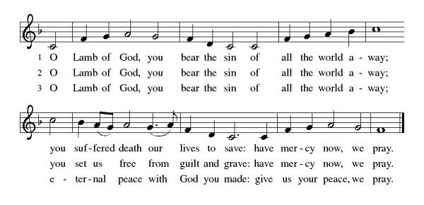

*Sit***Distribution of Holy Communion***Our congregation practices eucharistic hospitality.  We believe that the resurrected Christ is truly present in the bread and wine with his gifts of life, forgiveness of sin, and salvation.  All are welcome at the Lord’s table.  Please come to the altar to receive the bread and wine.  If you are wearing a mask, remove it to eat and drink the sacrament.  If you receive the wine, take a small cup, or you may intinct the host in the chalice. Place the small cups in the baskets on either side of the altar area.  Please return to your seat by the side aisles.*

**Communion Reflection:** Like a Shepherd, by Bob Dufford

**+SENDING+**

*Stand***BLESSING**The body and blood of our Lord Jesus Christ strengthen you and keep you in his grace.  **Amen.**

**PRAYER AFTER COMMUNION  
AM:** Let us pray. Jesus, Bread of life, **we have received from your table more than we could ever ask. As you have nourished us in this meal, now strengthen us to love the world with your own life. In your name we pray. Amen.**

**BENEDICTION**The Lord bless you and keep you.

The Lord shine on you with grace and mercy.

The Lord look upon you with favor and + give you peace. **Amen.**

*Sit*

**ANNOUNCEMENTS**

*Stand*

**SENDING HYMN- *ELW 645 Christ is Made the Sure Foundation***

**Dismissal:**

Go in peace. You are the body of Christ.

**Thanks be to God.**

**Postlude**- Allegro, by D. Zipoli

***Sundays and Seasons v.20220215.1125  
Copyright © Augsburg Fortress. All rights reserved.***

**Ongoing Prayers for:**

*For additions or deletions please e-mail or call the church office.789-7776, or lcgsmail@gmail.com*

Traci Purvis

Jessica Maynard

Bobbie Peterson

Nancy LaPelle

C. Duncan

Margaret Franks

Kathy Vigness Raposa

Billy Wernquest

Ruth Wernquest

Holly Deutsch

Ellen Bennett

Mary Jane Briggs

Bill Deutsch

Meredith Miller

Gary Durett

Natalie Schanck

Mike Carty

Barbara Smith

Eero Moisio

Phyllis Farley

Lane Leedahl

Brian Mitchell

Barney

Joyce Pearson

Daniel Deutsch

Amy Phillipo

Karolyn Lee

Liam Varnelis

Josh Peterson

Kathy Lee

Chris Rose

Colette Cusson

Dennis Murray

Lisa Ferry  
Ellora Hendrickson

Melvin Platt

KC Christensen

Jan Briggs

Ruth McGuy

Bud Godwin

Lisa Lessman

Taylor Lessman

Joan & Sheldon Pratt

Jerry Paquin

Stanley Larson

Ellen Hedlund

Donald & Bernadine Cunnigen,

Maggie Reichgott

Tucker Maute

Karen Perry

Mark Quinn

Carolyn Hathaway

Betty Hathaway

Tim Diskin

**+LOVED ONES IN THE ARMED FORCES**+ Manny Morales, Michael Bock

Matthew Kankash, Heath O’Neill, Andrew Anderson, Noah Cooper,

Dan Berkowitz